Yoga Philosophy Quiz

What does the concept of 'Atman' refer to in yoga philosophy?

B) The individual soul
Which of the following is not one of the yamas in Patanjali's Yoga Sutras?
- Ishvara Pranidhana (surrender to a higher power)
In Sanskrit, what does the term 'Dhyana' mean?
- Meditation
What does Krishna emphasise as essential for maintaining the order of the world in Chapter 3?
- Performing one's prescribed duties
In Chapter 2, which path does Krishna say leads to self-realization through the pursuit of knowledge and wisdom?
- Jnana Yoga
What is Arjuna's main dilemma at the beginning of Chapter 2?
B) He is reluctant to fight in the battle

True or False
Brahman is the ultimate, unchanging reality in the Upanishads, beyond the world of appearances.
- True
Samadhi is the final limb of the Eight Limbs of Yoga and represents a state of complete absorption.
- True
Bhujangasana is known as Child's Pose in English.
- False

Sukhasana means Easy Pose or Comfortable Pose in English.
- True
Asteya, one of the yamas, refers to truthfulness.
- False
The Bhagavad Gita is a classical text on yoga that is part of the Mahabharata.
- True

Name the eight limbs of yoga as outlined by Patanjali.
Yama (ethical restraints), Niyama (ethical observances), Asana (physical postures), Pranayama (breath control), Pratyahara (withdrawal of the senses), Dharana (concentration), Dhyana (meditation), Samadhi (absorption or enlightenment).
List the five yamas and briefly describe each one. 1 point for Sanskrit & 1 point for English
Ahimsa: Non-violence
Satya: Truthfulness
Asteya: Non-stealing
Brahmacharya: Celibacy or moderation
Aparigraha: Non-greed or non-possessiveness

What is the significance of the concept of 'Atman' in relation to 'Brahman' in Vedantic philosophy?
In Vedantic philosophy, 'Atman' refers to the individual soul, which is a manifestation of 'Brahman,' the ultimate reality or universal soul. Realizing the oneness of Atman and Brahman is the goal of many spiritual practices.

Describe the location and function of the 'Anahata' chakra.
The Anahata chakra, located at the heart, is associated with love, compassion, and emotional balance. It is the fourth chakra and is represented by the colour green and the element air.

Translate and explain the Sanskrit term 'Svadhyaya'.
'Svadhyaya' translates to 'self-study' or 'self-reflection.' It is one of the niyamas and involves the study of sacred texts and introspection to understand one's true nature.

What is the main goal of practicing yoga according to the Bhagavad Gita?
The main goal of practicing yoga according to the Bhagavad Gita is to achieve union with the Divine and attain self-realization.

Please write the Sanskrit Name for each pose

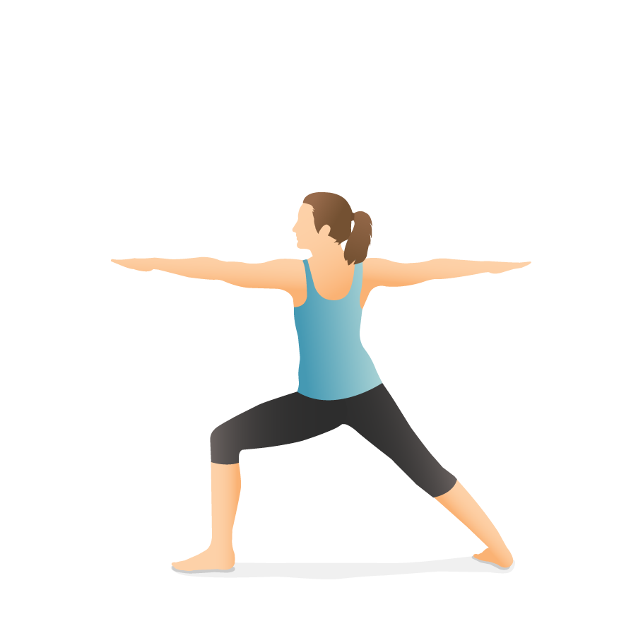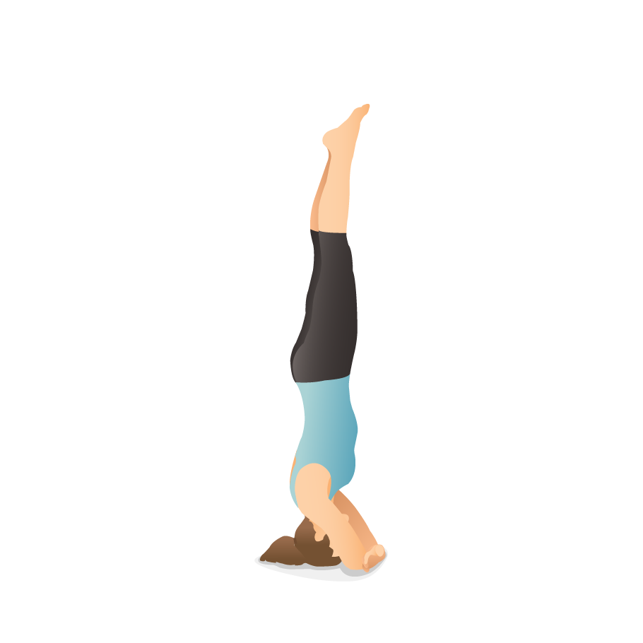
Sirsasana
Virabhadrasana II
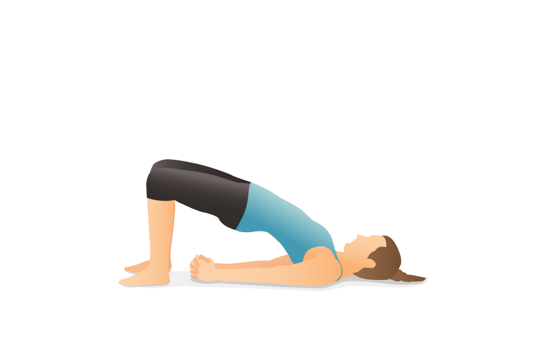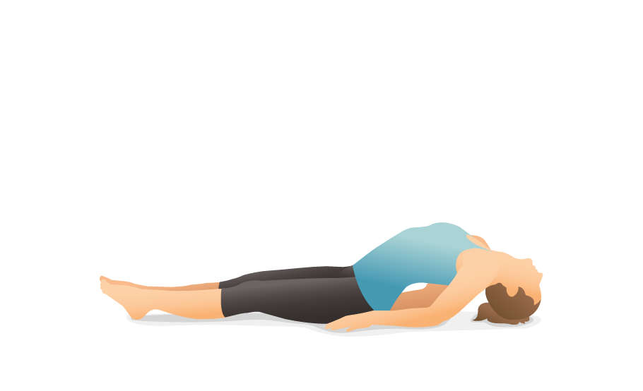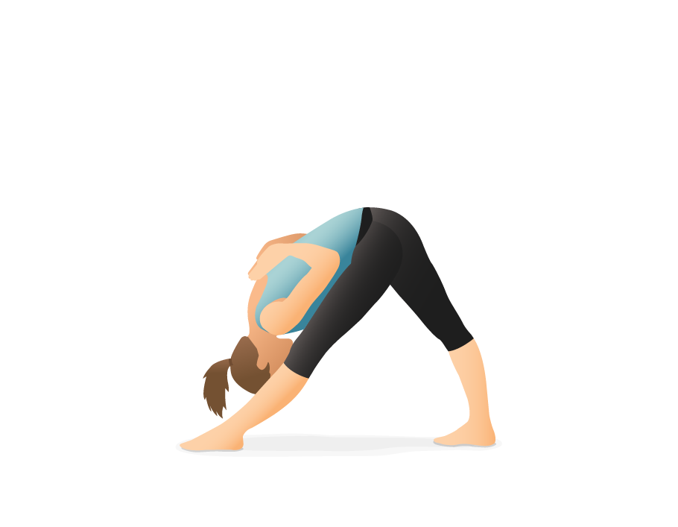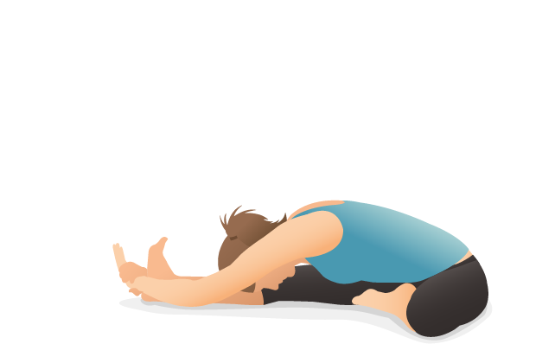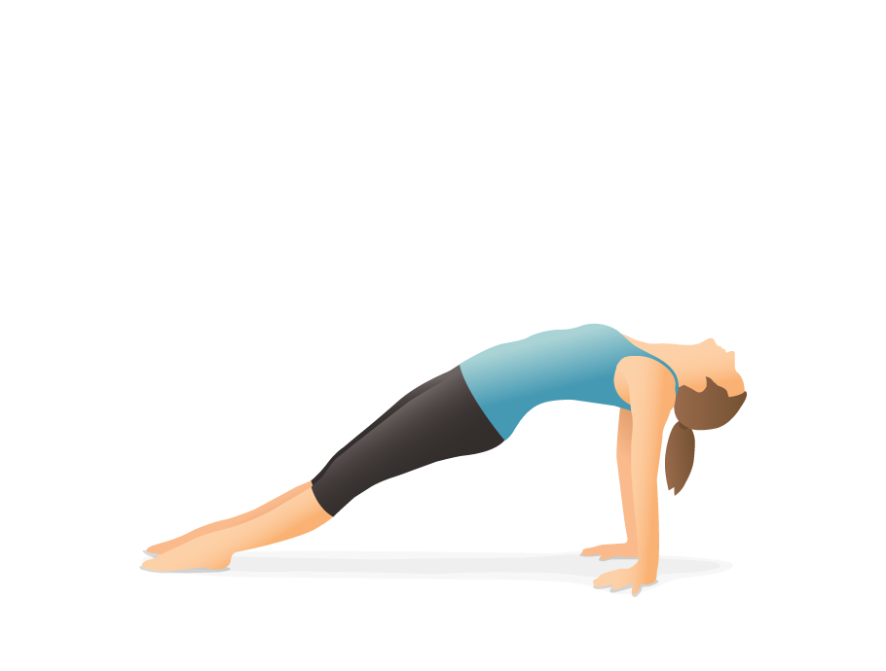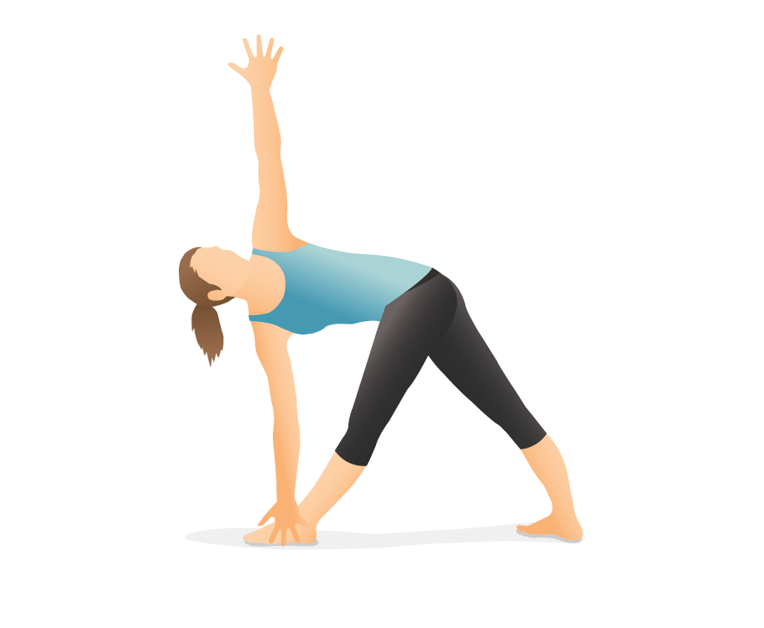
Trikonasana
Purvottanasana
Janu Sirsasana
Parsvottanasana
Matsyasana
Setu Bandhasana

